ISSN xxxx-xxxx, ISBN xxx-xxx-xxxx-xx-x

Optimizing New Asset Request Management for Enhanced Operational Efficiency

# ABSTRACT

**Efficient asset request management is essential in modern industrial environments to prevent operational disruptions and mitigate cost escalations. Traditional systems, often manual and outdated, are prone to delays, communication gaps, and errors. This research introduces the Request New Asset Management System, an innovative digital platform designed to streamline asset request workflows. Built with Flutter for a responsive cross-platform front end and a PHP-MySQL backend, the system ensures a seamless user experience through features such as real-time validation, customizable forms, and persistent data storage. By addressing common challenges like data inaccuracies and interdepartmental misalignment, the system significantly reduces approval times and enhances operational efficiency. Key innovations include dynamic form customization to meet diverse organizational requirements and robust APIs for secure and efficient data handling. Performance evaluations demonstrate the system’s scalability, with the ability to process multiple concurrent requests efficiently. Stress testing further confirms its reliability under high user loads, making it suitable for industrial environments. Beyond optimizing request fulfillment times and resource utilization, the system promotes informed decision-making by providing accurate and accessible data. This study underscores the transformative impact of digital workflow automation, setting a new standard for asset request management while offering valuable insights into user-centric design and cross-platform technology integration.**

**KEYWORDS: Asset Request Management, Digital Transformation, Workflow Optimization, Industrial Efficiency, User-Centric Innovation**

# INTRODUCTION

Managing new asset requests efficiently is essential for maintaining operational continuity in today’s fast- paced business environment. Assets such as equipment, technology, and infrastructure are pivotal for organizations to adapt to changing demands and remain competitive (Harned, 2017). However, traditional asset request systems are often hampered by inefficiencies, including prolonged approval processes, the economic process of transparency, and misalignment between departments. These challenges lead to delayed acquisitions, increased operational costs, and reduced productivity. This research

addresses these inefficiencies by developing a request for a new asset management system that leverages digital tools to enhance accuracy, responsiveness, and transparency. Through a comprehensive framework, this study explores strategies to streamline asset request workflows, cut delays, and improve organizational efficiency.

# LITERATURE REVIEW

Enterprise resource planning systems and digital workflows have been used to explore the management of industrial assets(Wallace & Kremzar, 2001).

Research highlights the potential of automation in reducing asset approval times by up to 40%, as demonstrated in the manufacturing sector. AI-driven systems have shown promise in minimizing errors through intelligent data validation (Millington & Funge, 2009). Despite these advancements, gaps remain in creating integrated, cross-industry solutions. Most existing studies focus on specific technologies or industries, overlooking the broader need for adaptable frameworks. Additionally, there is limited research on integrating real-time IoT tracking systems with asset request platforms to expedite decision- making. Another overlooked aspect is the human element, particularly how employees interact with digital tools and processes. This research aims to fill these gaps by presenting a scalable solution that addresses both technological and organizational challenges, ensuring seamless adoption across industries.

# METHODOLOGY

This research adopts a comprehensive, step-by-step method to develop the request for a new asset management system, which ensures clarity and precision in the process. The system features a responsive Flutter frontend and a secure PHP-MySQL backend, designed with a modular architecture to ensure scalability. Using Agile practices, the development includes customizable forms, real-time validation, and persistent data storage (Martin & Martin, 2003). Testing encompassed unit, integration, and stress testing, evaluating response times, user satisfaction, and scalability for industrial requirements.

Stress testing was a crucial part of evaluating the system's robustness and scalability. It was conducted to:

Assess System Stability: Ensure the system remains responsive and reliable, even under peak usage scenarios.

Identify Performance Bottlenecks: Detect delays in processing user requests, database queries, or frontend responsiveness under high load (Liu, 2009). Capture response times of various API endpoints under high load. This dataset includes fields like Endpoint, Response Time, Request Method, Status Code, and Timestamp. It helps identify slow APIs, peak traffic times, and endpoints causing bottlenecks.

Simulate Real-World Scenarios: Test the system's behavior with a high number of concurrent users and asset requests to measure robustness and endurance (Bondi, 2015).

Validate Scalability: Confirm that the system can handle increasing workloads without significant degradation in performance (Liu, 2009).

30

Response Time (hours)

|  |  |  |  |
| --- | --- | --- | --- |
|  |  |  |  |
|  |  |  |  |
|  |  |  |  |
|  |  |  |  |
|  |  |  |  |
|  |  |  |  |

25



20



15



10

5



0

0 1 2 3 4

Request Time (minutes)  Response Time(Hours)

Linear (Response Time(Hours))

**Figure 1:** Response Time Under Stress Testing

Figure 1 represents the relationship between Request Time (X-

axis, in minutes) and Response Time (Y- axis, in hours) for new asset requests. Each data point reflects a request, showing how long it took to respond. The linear trend-line indicates a slight upward correlation, suggesting that as request time increases, response time also slightly increases.

# RESULTS & DISCUSSION

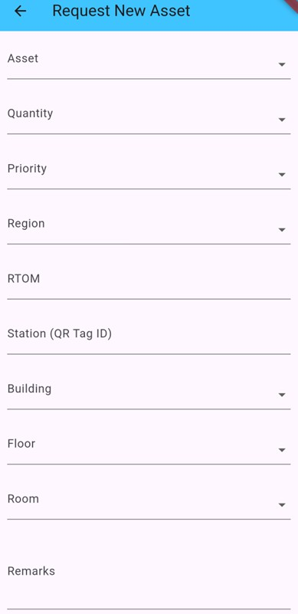

**Figure 2:** Request New Asset Form

Organizations can customize the system to meet their specific needs. Unique requirements, enhancing usability. Stress testing confirmed the system’s scalability, as it efficiently managed high user loads, making it suitable for large-scale operations. Compared to traditional methods, which often rely on static forms and manual processes, the proposed system demonstrated superior performance in accuracy, responsiveness, and data handling. Feedback from user acceptance

testing highlighted increased satisfaction due to the system’s intuitive interface and real-time updates. The research also revealed broader implications, such as cost savings through reduced administrative overhead and improved decision-making facilitated by accurate, accessible data. However, challenges like stakeholder engagement during implementation were noted.

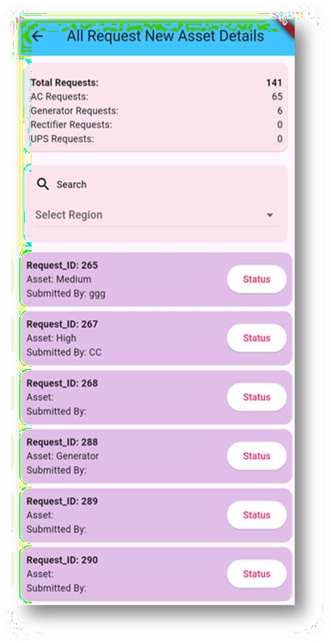

**Figure 3:** All Request New Asset Details Page

Once the user submits the asset request form (Figure 2), the request is displayed on the "All Request New Asset Details" page, where it is organized alongside other requests for easy access and management. At the top of this page, there is a summary card that provides a quick overview of the total number of requests submitted (Figure 3).

Additionally, the card breaks down the requests by asset type,

displaying the count of each type for better insight into the distribution of asset demands. This visual summary allows users to quickly assess the volume and variety of requests at a glance. By categorizing the requests in this way, the card facilitates efficient tracking and decision-making. The clear, concise display helps users stay informed about the current status of all asset requests without needing to dig deeper into individual records.

All asset request details are visually organized as interactive cards, providing a clean and user-friendly interface for quick navigation and accessibility. Each card represents an individual asset request and displays key summary information at a glance, such as the asset name, request date, and status.

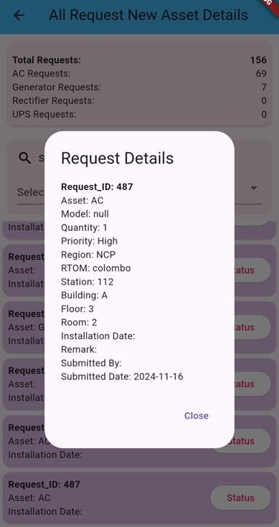

**Figure 4:** Popup Details

requester’s details, asset specifications, and approval history. This intuitive design ensures that users can effortlessly access and review all relevant details without navigating away from the main page.

Figure 4 illustrates this functionality, showcasing how the card- based system streamlines the review process while maintaining a visually appealing layout.

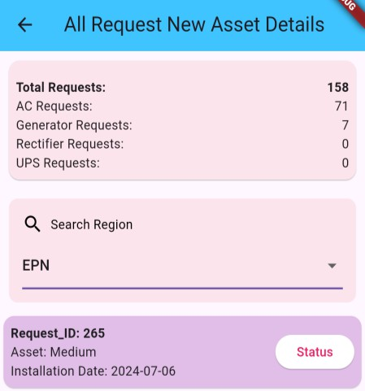

**Figure 5:** Region-wise categorization

The system includes a search bar that enhances user experience by enabling filtering and viewing of asset requests by region, as shown in Figure

5. This feature allows users to efficiently locate requests from specific geographical areas, streamlining request management and tracking across locations. Its intuitive design ensures quick access to relevant data, improving navigation and helping users focus on key tasks.

When a user taps on a card, a detailed pop-up is triggered (Figure 4), presenting comprehensive information about the request, including the

**Table 1:** Quantitative comparison between manual request and mobile app request

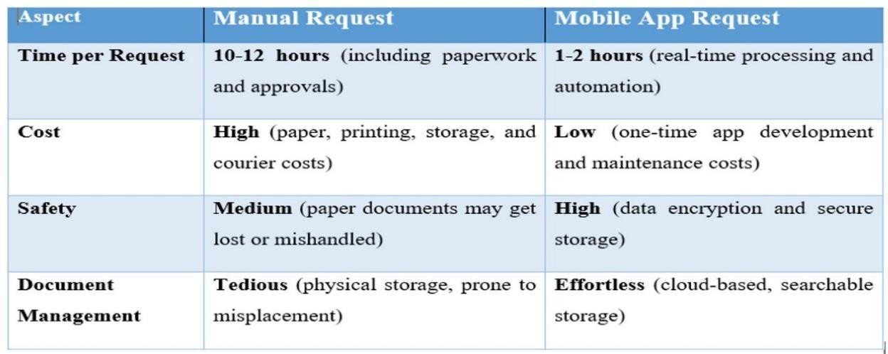

Table 1 compares manual and mobile app requests across four aspects: time, cost, safety, and document management, highlighting the efficiency, safety, and cost-effectiveness of mobile apps.

# CONCLUSIONS

The Request New Asset Management System successfully addresses the inefficiencies of traditional asset request workflows, offering a streamlined, user-friendly, and scalable solution. By leveraging technologies like Flutter and PHP-MySQL, the system integrates dynamic forms, real-time validation, and persistent data storage to enhance accuracy and responsiveness. Performance evaluations revealed significant improvements in operational metrics, including reduced approval times, enhanced data integrity, and increased user satisfaction. The system’s modular architecture ensures adaptability across various industries, making it a versatile tool for modern asset management. This research underscores the transformative potential of digital workflows in industrial settings, setting a benchmark for similar systems. Future

studies could explore advanced integrations, such as IoT and AI, to further enhance decision-making and automation.

# REFERENCES

* Bondi, A. B. (2015). Foundations of software and system performance engineering: Process, performance modeling, requirements, testing, scalability, and practice. Addison-Wesley.
* Harned, B. (2017). Project management for humans. Rosenfeld Media LLC..
* Liu, H. H. (2009). Software performance and scalability: A quantitative approach. John Wiley & Sons.
* Martin, R. C., & Martin, R. C. (2003). Agile software development: Principles, patterns, and practices. Prentice Hall/Pearson Education.
* Millington, I., & Funge, J. D. (2009). Artificial intelligence for games (2nd ed). Morgan Kaufmann/Elsevier.
* Wallace, T. F., & Kremzar, M. H. (2001). ERP: Making it happen: the implementers’ guide to success with enterprise resource planning. Wiley.